**A Five forces model for IKEA**

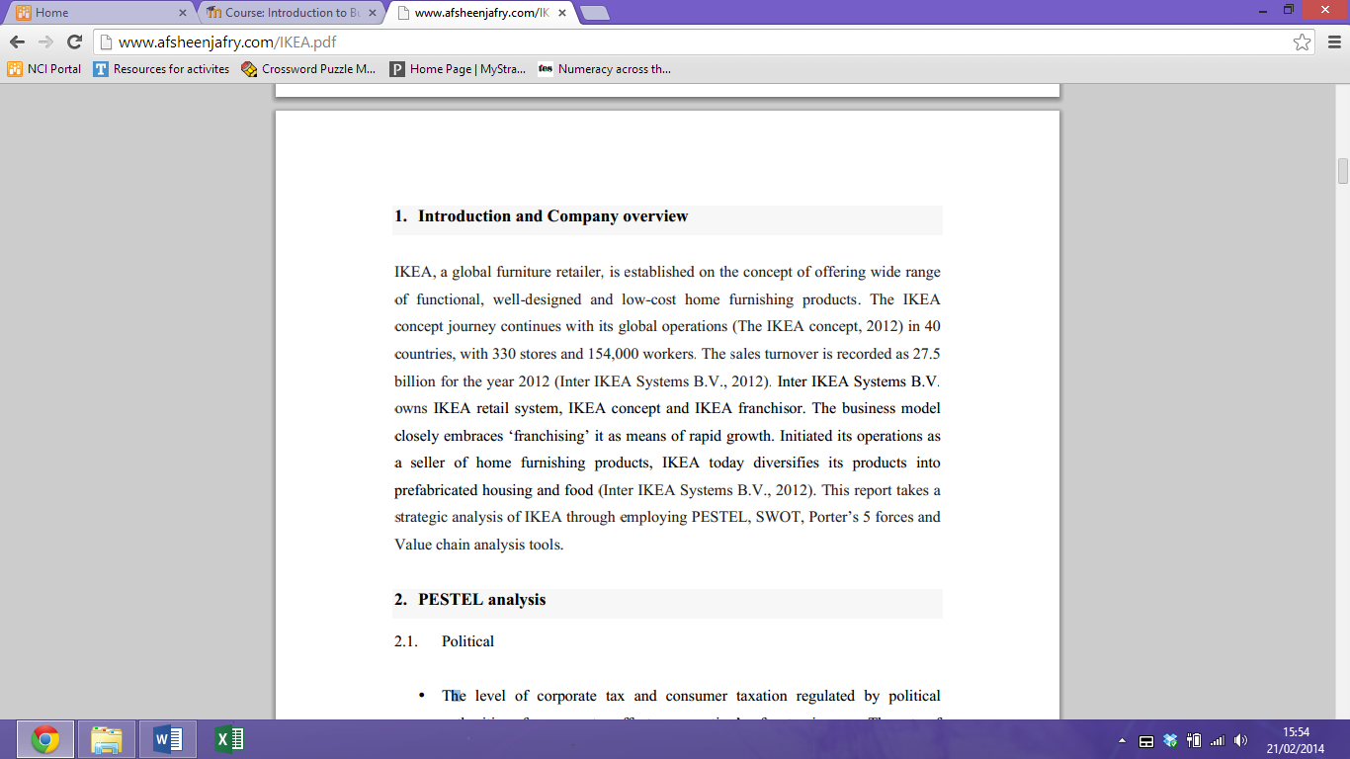

**Force 1: The degree of Rivalry**

**Force 2: The threat of Entry**

**Force 3: The threat of substitutes**

**Force 4: Buyer Power**

**Force 5: Supplier Power**